**Error Handling with Express Validator**

express-validator is a package that supports data validation and can be used to integrate with the NodeJS express framework to validate API request parameters.

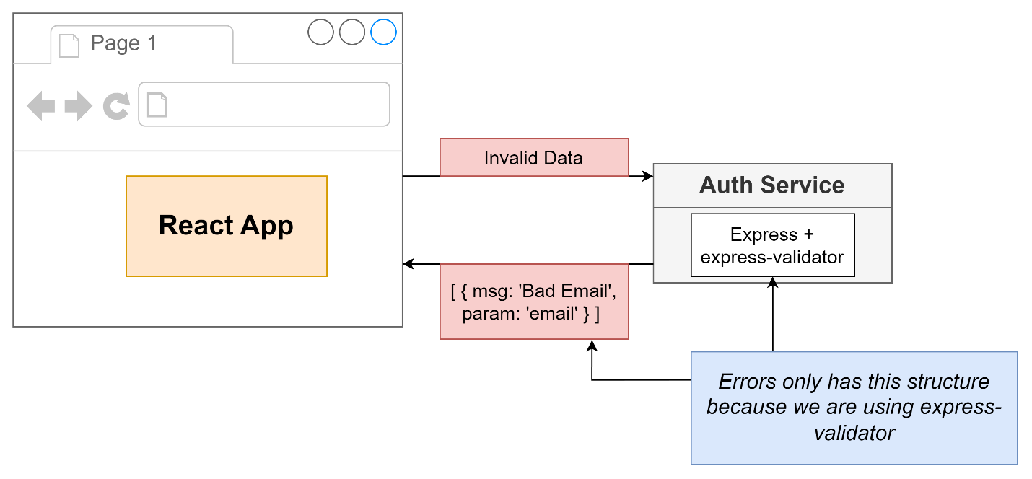

**Error handling can get complex !**

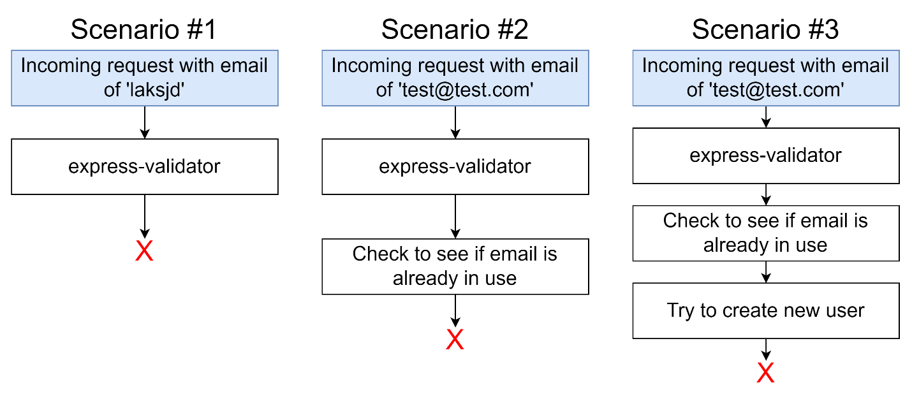

**Error handling for sending an identically-structured response**

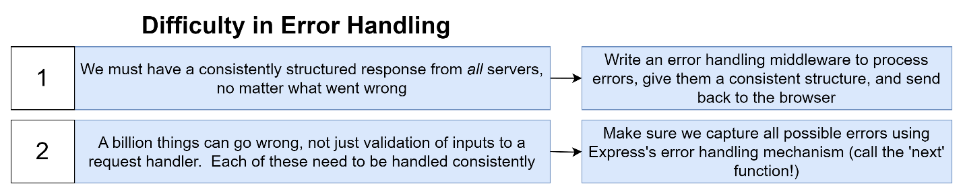

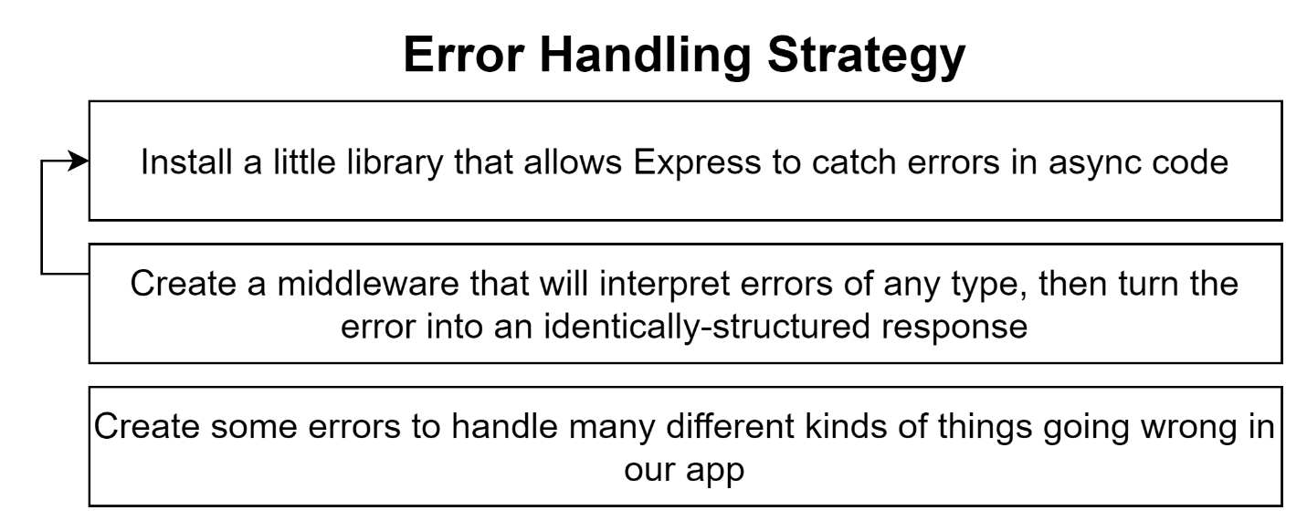

**Error handling using Middlewares**

